

Two dimensional steady state heat transfer and temperature distribution over the annular plate with convection
Course Title – Finite Element Method
Course Code – ME 436/736

Submitted To
Sandeep singh
Department of Mechanical Engineering IIT Indore
Submitted By
Chandan Maurya
(2502103017)

1. Introduction and Problem Statement
This project investigates the steady-state temperature distribution over a two-dimensional annular plate (a circular ring) using the Finite Element Method (FEM). The analysis incorporates Fourier's Law of Conduction and a Robin boundary condition for heat transfer via convection.

2. Geometry and Material Properties

Inner radius | 0.5 m
Outer radius | 1 m
Thermal conductivity | 10 W/(m. K)
Heat transfer coefficient | 25 W/(m²·K)
Ambient temperature | 100 K
Internal radius temperature | 400 K

3. Governing equation

For 2D steady-state heat conduction with internal heat generation , the governing partial differential equation is the Poisson Equation

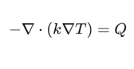
Weak Form
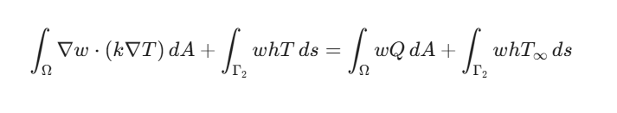

4.Methodology

clear;
clc;
close all;

% Data
ri = 0.5;
ro = 1.0;
k = 10.0;
h = 25.0;
Tinf = 100.0;
Tinner = 400.0;
Q = 0.0;

nr = 5;
ntheta = 32;

% Mesh generation
rvec = linspace(ri, ro, nr);
theta = linspace(0, 2*pi, ntheta+1);
theta(end) = []; % remove duplicate

nodes = zeros(nr*ntheta,2);
nid = zeros(nr, ntheta);
id = 0;
for i = 1:nr
for j = 1:ntheta
id = id + 1;
nodes(id,1) = rvec(i)*cos(theta(j));
nodes(id,2) = rvec(i)*sin(theta(j));
nid(i,j) = id;
end
end
nNodes = size(nodes,1);

% Connectivity
elems = [];
for i = 1:nr-1
for j = 1:ntheta
jp = j + 1;
if jp > ntheta,
jp = 1;
end
elems = [elems; nid(i,j) nid(i,jp) nid(i+1,jp) nid(i+1,j)];
end
end
nElem = size(elems,1);

function [N, dN_dxi] = shapeQ4(xi, eta)

% Shape functions (1x4 vector)
N1 = 0.25*(1-xi)*(1-eta);
N2 = 0.25*(1+xi)*(1-eta);
N3 = 0.25*(1+xi)*(1+eta);
N4 = 0.25*(1-xi)*(1+eta);

N = 0.25 * [(1-xi)*(1-eta), (1+xi)*(1-eta),(1+xi)*(1+eta), (1-xi)*(1+eta)];

% Derivatives w.r.t. xi and eta
dN_dxi = 0.25 * [-(1-eta), (1-eta), (1+eta), -(1+eta); -(1-xi), -(1+xi), (1+xi), (1-xi)];

end

%% Global matrices
K = sparse(nNodes,nNodes);
F = zeros(nNodes,1);

% 2x2 Gauss
g = 1/sqrt(3);
gp = [-g -g; g -g; g g; -g g];
w = [1 1 1 1];

% Element loop
for e = 1:nElem
conn = elems(e,:);
Xe = nodes(conn,:);
Ke = zeros(4,4);
fe = zeros(4,1);
for kq = 1:4
xi = gp(kq,1);
eta = gp(kq,2);
[N, dN_dxi] = shapeQ4(xi, eta);
J = dN_dxi * Xe;
detJ = det(J);
invJ = inv(J);
dN_dx = invJ * dN_dxi; % 2x4
Ke = Ke + k * (dN_dx' * dN_dx) * detJ * w(kq);
if Q ~= 0
fe = fe + N' * Q * detJ * w(kq);
end
end
K(conn,conn) = K(conn,conn) + Ke;
F(conn) = F(conn) + fe;
end

% Convection on outer boundary
gp1d = [-1/sqrt(3), 1/sqrt(3)];
w1d = [1, 1];
for j = 1:ntheta
jp = j + 1; if jp > ntheta, jp = 1;
end
n1 = nid(nr,j);
n2 = nid(nr,jp);
x1 = nodes(n1,1);
y1 = nodes(n1,2);
x2 = nodes(n2,1);
y2 = nodes(n2,2);
L = sqrt((x2-x1)^2 + (y2-y1)^2);
Je = L/2;
Ke_edge = zeros(2,2);
fe_edge = zeros(2,1);
for gq = 1:2
s = gp1d(gq);
N1 = (1-s)/2;
N2 = (1+s)/2;
Nedge = [N1 N2];
Ke_edge = Ke_edge + (Nedge'*h*Nedge) * Je * w1d(gq);
fe_edge = fe_edge + (Nedge'*h*Tinf) * Je * w1d(gq);
end
idx = [n1 n2];
K(idx,idx) = K(idx,idx) + Ke_edge;
F(idx) = F(idx) + fe_edge;
end

%Dirichlet inner boundary
fixed = nid(1,:);
T = zeros(nNodes,1);
T(fixed) = Tinner;

F = F - K*T;
K(fixed,:) = 0; K(:,fixed)=0;
for ii = fixed
K(ii,ii) = 1;
F(ii) = T(ii);
end

% Solve
T = K\F;

% Results
fprintf('Min T = %.2f K, Max T = %.2f K\n', min(T), max(T));

% Convert quads to triangles for plotting
tri = zeros(2*nElem,3);
for e = 1:nElem
c = elems(e,:);
tri(2*e-1,:) = c([1 2 3]);
tri(2*e,:) = c([1 3 4]);
end

figure('Color','w');
trisurf(tri, nodes(:,1), nodes(:,2), T, 'EdgeColor','none');
view(2); axis equal; colorbar;
title('Temperature Distribution (K)');
xlabel('x (m)'); ylabel('y (m)');

5.Result and Discussion

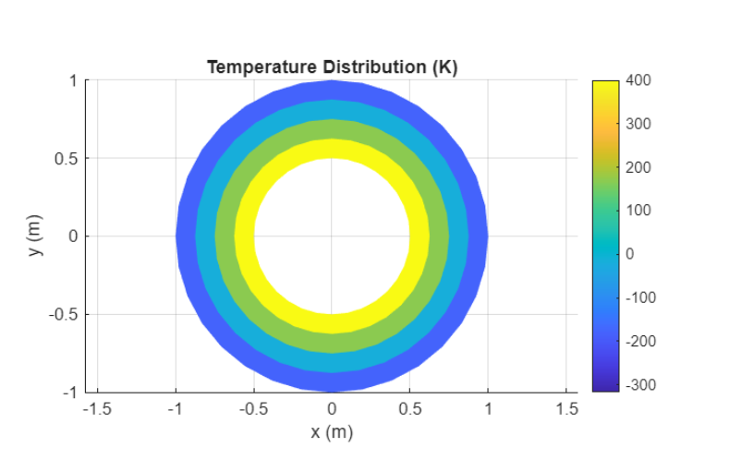
The simulation result shows the temperature T across the x-y plane The plot confirms that the highest temperatures are maintained at the inner radius, and heat is smoothly transported to the outer convection boundary.
Maximum temperature= 400k ,Minimum Temperature=-316.82

